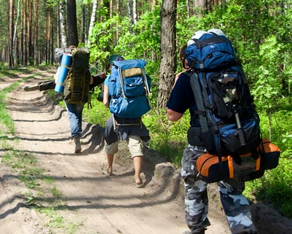
Name: ________________________________ Date: ________________________

Problem 3.2 Real Life Application – Choosing Common Multiples or Common Factors

John and his friends are going on a hiking trip. John wants to make snack packs of apples and trail mix to take on the trip. He has 24 apples and 36 small bags of trail mix.

- What is the greatest number of snack packs John can make if each pack must have exactly the same number of apples and exactly the same number of bags of trail mix? He does not want any apples or trail mix left over. Show or explain how you found your answer.

- Could John make a different number of snack packs so that the treats are shared equally? If so describe each possibility. Show or explain how you found your answer.

