Name: _________________________________ Date: _________________________ HR: _____

Lesson: Percent of a Quantity

1. Five of the $25$ girls on Alden Middle School’s soccer team are seventh-grade students. Find the percentage of seventh graders on the team. Show two different ways of solving for the answer. One of the methods must include a double number line or tape diagram and the other must be using equivalent ratios (proportion).

2. Of the $25$ girls on the Alden Middle School soccer team, $40\%$ also play on a travel team. How many of the girls on the middle school team also play on a travel team? Use a proportion to solve.

3. The Alden Middle School girls’ soccer team won $80\%$ of its games this season. If the team won $12$ games, how many games did it play? Solve the problem using a proportion.

Additional Practice

- What is $15\%$ of $60$? Create a model to prove your answer.

- If $40\%$ of a number is $56$, what was the original number? Use a proportion to solve.

- In a $10×10$ grid that represents $800$, one square represents ________________________

Use the grids below to represent $17\%$ and $83\%$ of $800$.
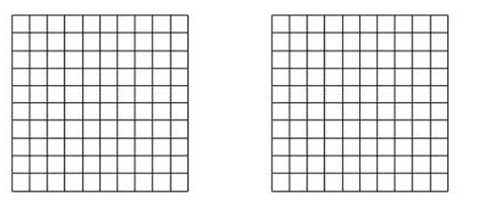
$$83\%$$
$$17\%$$

$17\%$ of $800$ is __________________. $83\%$ of $800$is _________________.

