Name: _____________________________________ Date: __________________ HR: ________

Lesson: Finding Distance Between Two Points on the Coordinate Plane.

Use the picture below to answer the questions.

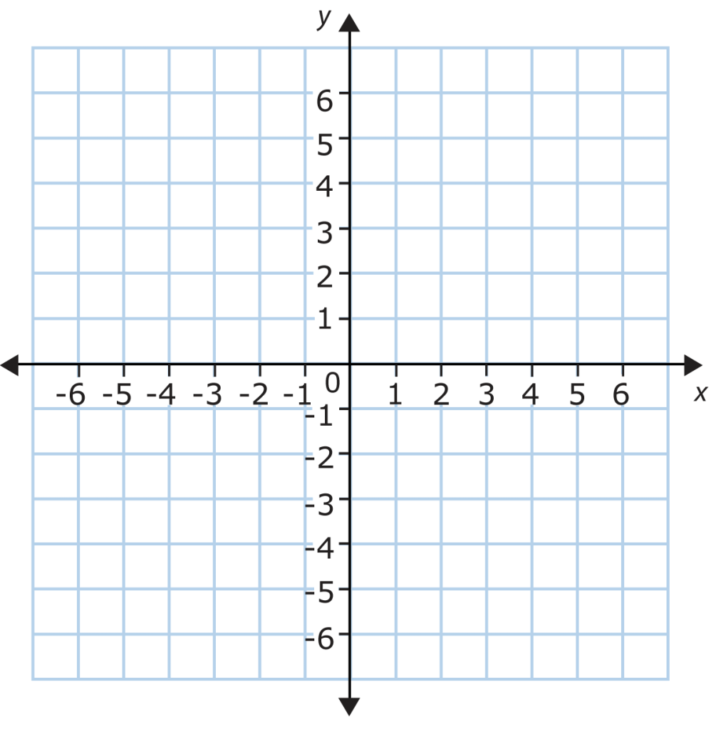

Part 1
- Write the coordinates of point A and point B. In which quadrant(s)are the located?

- Find the distance between those two points. Explain how you found your answer.

- Use a different strategy to find the distance between those two points. Explain.

Part 2
- Write the coordinates of point C and point D. In which quadrant(s) are the located?

- Find the distance between those two points. Explain your work.

- Use a different strategy to find the distance between those two points. Explain

Part 3
- The coordinates of point E are (6, 2) and the coordinates of point F are (6, -2).

- Find the distance between them with out graphing the points.

- Explain to someone how to find the distance between two points (horizontally and vertically only) on the coordinate plane. Be very specific.

