Name: ______________________________________ Date: ________________ HR: _________

HOMEWORK – Positive & Negative Numbers on the Number Line

Problems
1. On the number lines below plot the points: -2, 4, and 6.
a. Graph and label the opposites of each point.
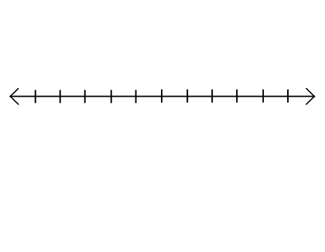

b. Explain how you found the opposite of each point.

2. Carlos uses a number line like the one below to graph the points -4, -2, 3, and 4. He notices that -4 is closer to zero than -2. He is not sure about his diagram.

a. What do you think Carlos did? Graph it.

b. Did Carlos make a mistake or not? Explain

3. Choose an integer between -5 and -10. Label it R on the number line below and complete the following tasks.

a. What is the opposite of R? Label it Q.
b. State a positive integer greater than Q. Label it T.
c. State a negative integer greater than R. Label it S.
d. State a negative integer less than R. Label it U.
e. State an integer between R and Q. Label it V.

4. Will the opposite of a number always be a negative number? Explain your reasoning.

