Station 1
Buying Yogurt

Ms. Colon’s son loves yogurt. She’s at Market Basket and noticed the two different packages shown below.

Which yogurt package should Ms. Colon get?

1 package of 6 yogurts $3.00

1 package of 12 yogurts $4.80

Station 2
Buying a Car

Justin wants to buy a new car. After doing some research, he narrowed down his options to a 2016 Honda Accord or a 2016 Toyota Camry Sports Edition. He likes all features on both cars. However, he determined that the car that is more gas efficient will be the one he buys, as he commutes about 2 hours daily.

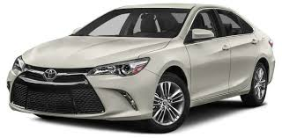
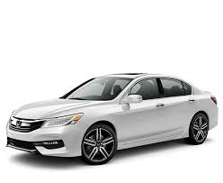
Which car should he get?
2106 Toyota Camry SE
105 highway miles /3 gallons of gas
2106 Honda Accord
160 highway miles /4 gallons of gas

Station 3
Sporting Stores

The weekend newspaper featured an ad for Olympia Sport and another for Finish Line.

Which store gives the better deal?

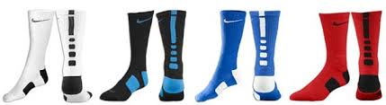
4 pairs for $52

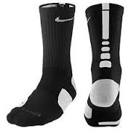

1 pair for $14

Station 4
Fastest Runner

Tim, Jason, and Sam are all member of the track team at the Wang Middle School.

Who is the fastest runner?

Tim Jason Sam
18 minutes/3 miles 7 minutes/1 mile 12 minutes/2 miles

