Name: ________________________________ Date: _________________ HR: _____

Homework 4 – Using a Venn Diagram to find GCF

For each set of numbers below;
- List all the factor pairs of each number;
- Label and complete the Venn diagram;
- Identify the GCF
- Tell whether or not the numbers are relatively prime.

a. 54 and 40
54 40 Factors Factors
of 54 of 40

b. 48 and 64

48 64 Factors Factors
of 48 of 64

c. 80 and 40

80 40 Factors Factors
of 80 of 40

d. 17, 29, and 20

17 29 20

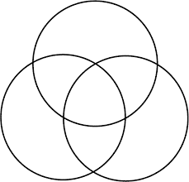
Factors
of 17

Factors Factors
of 29 of 20

