acolon@lowell.k12.ma.us
6th Grade Math with Ms. Colon
www.mathwithmscolon.weebly.com
Supplies - Bring to Class Everyday!  - Agenda  - Binder  - Pencils  - Erasers  - Color Pens  - Great Attitude for learning | Topics Covered:  - Factors, GCF  - Multiples, LCM  - Distributive Property  - Prime Factorization  - Exponents  - Prime, Relatively Prime  - Composite  - Square  - Whole divided by a fraction  - Fraction divided by a whole  - Fraction divided by fraction  - Mixed divided by mixed  - Ratios  - Rates  - Unit Rates  - Equivalent Ratios  - Tape diagrams  - Double Number lines  - Tables & Graphs  - Percent  - Integers  - Number Line  - Absolute Value  - Coordinate plane  - Distance between points  - Polygons on the plane  - Inequalities  - Expressions & Equations  - Area, Circumference, Surface area  - Nets  - Volume  - Line plots, Bar graphs, Circle graph  - Histogram, Box Plot  - Interquartile range  - MAD  - Mean, median, mode, range
Grade Policy:
- Conduct A, B, C, D, or F
- Effort A, B, C, D, or F

- Grade:
90 - 100 A
80 – 89 B
70 – 79 C
65 – 69 D
64 – below Failing

50% Unit Test, Benchmarks, Unit Projects
35% Quizzes, Check-Ins
15% Homework
Classroom Expectations:
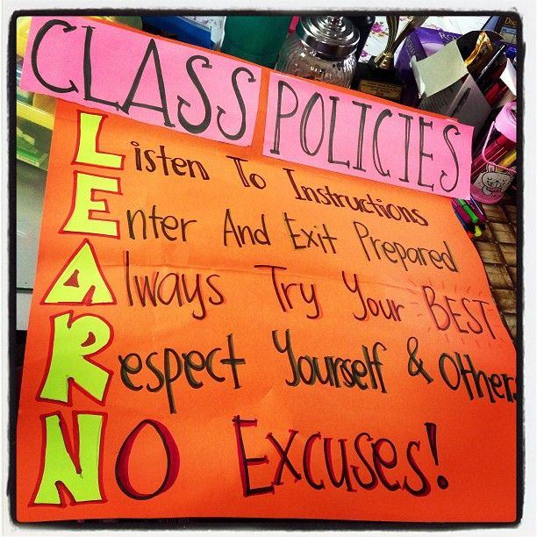
L isten to Instructions
E nter and Exit the Room Prepared
A lways Try Your Best
R espect Yourself & Others
N o Excuses!
Units Covered:
- Number System
- Fraction Operation
- Rates & Ratios
- Integers & The Coordinate Plane
- Expressions & Equations
- Geometry
- Statistics

Consequences:  When a student does not follow our classroom and behavior expectations the teacher will:  - Call or send an email to the parent  - Write a note on the agenda  - Schedule a meeting  - Refer student to the office  Through out the year we will be planning activities to reward the students who follow our classroom & behavior expectations. However if a student receives an office detention, Saturday detention, suspension, or has more than 3 missing homework assignments in one subject, she/he will not be allowed to attend the reward activity | Behavior Expectations:  PRIDE  Participation – In order to be successful this year, we expect all students to be actively engaged in classroom discussions, group work and independent work.  Respect – Students are expected to show respect towards one another, materials, and professionals at the Wang, etc.  Integrity – Students are expected to make good choices at all times.  Dedication – Students are expected to be prepared for their learning by making sure homework and class work is accurate and complete, asking for help when they need it, and studying for tests and quizzes.  Empathy – Students are expected to use cooperation and teamwork to achieve their goals inside and outside of the classroom.
Homework Policy:
- Write your homework in your agenda and get it signed by the teacher everyday.
- Bring your homework to class daily.
- If you are absent, it is your responsibility to get the homework from the class website, a friend, or the next day from the “extra basket”. It will be due the next day.
- If you miss more than 3 homework assignments you will not be allowed to participate on the reward activity.
- Homework is graded for completion and effort. If you do not understand a problem you are responsible for asking the teacher for help the next day.
Technology in the Classroom:
Through out the year we will be using laptops and iPads to enhance our learning of mathematics. Students are expected to follow instructions and stay on task. If a student enters an website other than what the teacher is using and/or takes pictures or videos of him/herself and/or other students, that student will NOT be allowed to continue to use the technology in the classroom.
Class Website:
www.mathwithmscolon.weebly.com

